CHEMISTRY WORKSHEET Page 1

NAME THE FOLLOWING | WRITE FORMULAS FOR THE FOLLOWING
1. Li₂O | 1. zinc hydroxide
2. KMnO₄ | 2. gold (I) acetate
3. (NH₄)₂CO₃ | 3. diselenium pentoxide
4. Fe(OH)₃ | 4. carbon monoxide
5. N₂O₃ | 5. nickel (III) sulfite
6. Cu(NO₃)₂ | 6. cobalt (II) nitrate
7. SeO₂ | 7. strontium chloride
8. CCl₄ | 8. silicon tetrachloride
9. BaCr₂O₇ | 9. lead (II) carbonate
10. SrCrO₄ | 10. copper (II) sulfate
11. P₂O₅ | 11. tin (IV) dichromate
12. Mn₃(PO₄)₇ | 12. phosphorus triiodide
13. Ag₃PO₃ | 13. iron (III) nitrite
14. CO₂ | 14. potassium permanganate
15. AlCl₃ | 15. sodium chlorate
16. NaOH | 16. diarsenic hexaoxide
17. Sn(CN)₄ | 17. tungsten (V) hypochlorite
18. Zn(NO₃)₂ | 18. barium chromate
19. SO₃ | 19. potassium hydroxide
20. NaC₂H₃O₂ | 20. ruthenium (III) sulfite

Write the formula for each of the acids listed below: Page 2
NAME THE FOLLOWING | WRITE FORMULAS FOR THE FOLLOWING
- HClO₄ | - Nitric acid
- H₃PO₄ | - Chloric acid
- HCl _{(aq)} | - Acetic acid
- H₂SO₄ | - Hydrobromic acid
- HNO₂ | - Sulfurous acid
- HI _{(aq)} | - Chlorous acid
- HC₂H₃O₂ | - Hydrochloric acid
- HF _{(aq)} | - Phosphoric acid
- H₃PO₃ | - Nitrous acid
- HClO₃ | - Hydrofluoric acid
- H₂CO₃ | - Perchloric acid
- H₂SO₃ | - Hydroiodic acid
- HClO₂ | - Phosphorous acid
- HNO₃ | - Carbonic acid
- HBr _{(aq)} | - Sulfuric acid

Chemistry: Errors in Chemical Formulas and Nomenclature Page 3
Each of the following formulas or chemical names contains an error. Correct each example.

1. aluminum (III) iodide 1. ______________________

2. Al₃O₂ 2. ______________________

3. (NH₄)₃Cl₂ 3. ______________________

4. lead (III) oxide 4. ______________________

5. leadic oxide 5. ______________________

6. stannous (II) bromide 6. ______________________

7. monocalcium dioxide 7. ______________________

8. K(ClO₂) 8. ______________________

9. (OH)₃Al 9. ______________________

10. Cr₄(CN)₃ 10. ______________________

11. Pb(NO₃)₃ 11. ______________________

12. copper (I) chloric 12. ______________________

13. ferric (III) oxide 13. ______________________

14. NiNO₃₂ 14. ______________________

15. Mg₂F 15. ______________________

16. ironic oxide 16. ______________________

17. ClK 17. ______________________

18. Ca₂O₂ 18. ______________________

19. sodium (I) fluoride 19. ______________________

20. dititanium tetroxide 20. ______________________

21. dihydrogen oxide 21. ______________________

22. magnesium dihydroxide 22. ______________________

23. cuprous (I) sulfate 23. ______________________

24. strontium difluoride 24. ______________________

25. NO₃Na 25. ______________________
Name the following alkanes Page 4

1. ________________________ 2. ___________________________
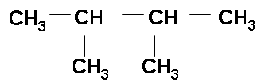
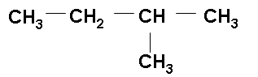

3. ________________________ 4. ___________________________

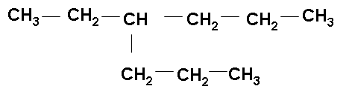
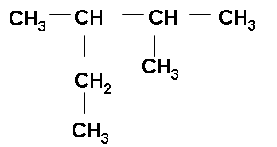

5. ________________________ 6. __________________________
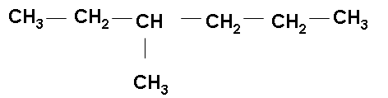
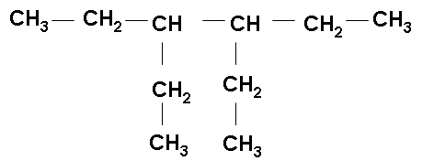

Draw these molecules:

7. 2, 2, 4-trimethyl pentane 8. 2, 3-diethyl 4-propyl octane

9. 3, 4-diethyl 2,2-dimethyl 3-propyl decane

